ILLINOIS POLLUTION CONTROL BOARD
July 26, 2018
IN THE MATTER OF:  UIC UPDATE, USEPA REGULATIONS (January 1, 2018 through June 30, 2018) | )  )  )  )  ) | R19-9  (Identical-in-Substance Rulemaking - Land)
Proposed rule. Dismissal order.
ORDER OF THE BOARD (by C.K. Zalewski):
Section 13(c) of the Environmental Protection Act (Act) (415 ILCS 5/13(c) (2016)) requires the Board to adopt regulations that are “identical in substance” to regulations of the United States Environmental Protection Agency (USEPA). 415 ILCS 5/7.2 (2016). Specifically, Section 13(c) relates to underground injection control (UIC) regulations that USEPA adopted to implement provisions of the Safe Drinking Water Act (42 U.S.C. §§ 300h et seq. (2016)). USEPA has codified its UIC regulations at 40 C.F.R. 144 through 148.
The Board reserved this docket for any UIC amendments adopted by USEPA between January 1, 2018 through June 30, 2018. During that period, USEPA took no action regarding its UIC regulations that will require Board action. Therefore, the Board dismisses this docket.
IT IS SO ORDERED.
I, Don A. Brown, Clerk of the Illinois Pollution Control Board, certify that the Board adopted the above order on July 26, 2018, by a vote of 5-0.
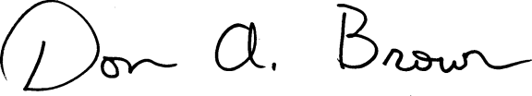
Don A. Brown, Clerk
Illinois Pollution Control Board

